App Enhancements

(Document best viewed in Ms-Word with Navigation Pane enabled to jump through the sections topics)

# **Room Building & Location Enhancement Change**

## Application Previews

### Room Add Page

### List Rooms Information Page

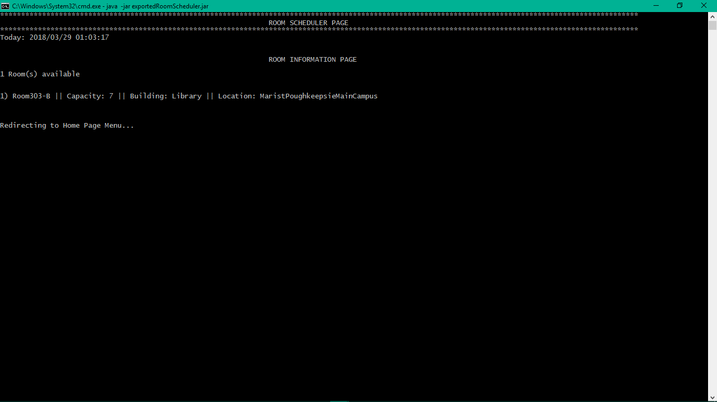

### Room Schedule Page

### Scheduled Room Info Page

## UNIT TESTING RESULTS

As of 29th March 2018. (Refer the Maven SureFire Report section below STATIC TOOL ANALYSIS in this document titled “Take 2: as of 29th March 2018” to view the test site output)

Maven Results

-------------------------------------------------------

T E S T S

-------------------------------------------------------

Tests run: 13, Failures: 0, Errors: 0, Skipped: 0, Time elapsed: 0.608 sec

Running test.java.RoomTest

Tests run: 10, Failures: 0, Errors: 0, Skipped: 0, Time elapsed: 0.001 sec

……

Results :

Tests run: 23, Failures: 0, Errors: 0, Skipped: 0

……

[INFO] ------------------------------------------------------------------------

[INFO] BUILD SUCCESS

[INFO] ------------------------------------------------------------------------

[INFO] Total time: 27.485 s

[INFO] Finished at: 2018-03-29T01:42:05-04:00

[INFO] Final Memory: 40M/317M

[INFO] ------------------------------------------------------------------------

## Maven SureFire Report

### Take 2: as of 29th March 2018

# **Revealing Rooms based on user’s input date-time duration**

## Application Previews

### Available Room Information – List Rooms Option

### Scheduled Room Information Page – List Scheduled Room Option

* Note the CodingRoom here. It alone being scheduled. So, when the user inputs the same timing date rage of this CodingRoom and requests to reveal all available rooms that does not conflict the given timing date range, the program should reveal all rooms except CodingRoom (refer next image)

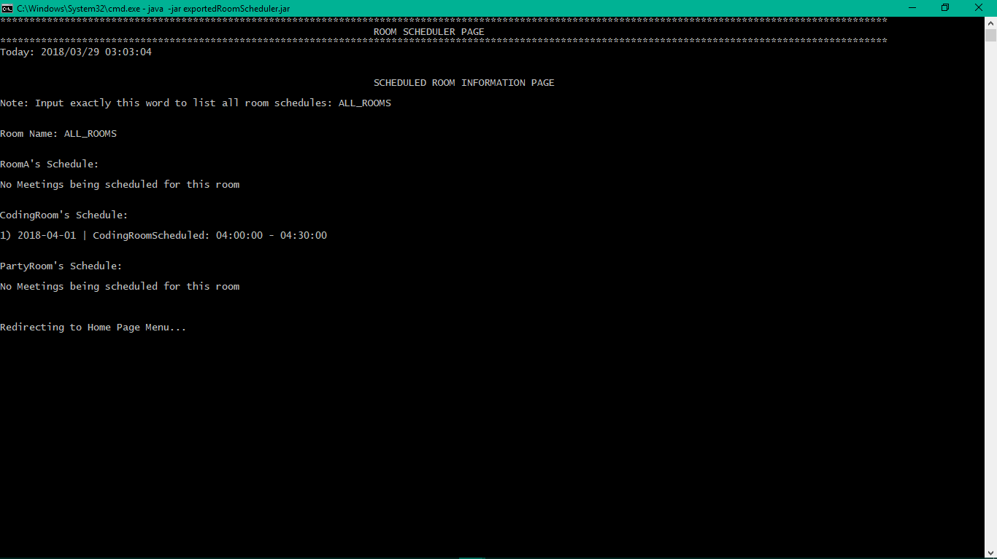

### Schedule Room Page – Schedule Room Option

* 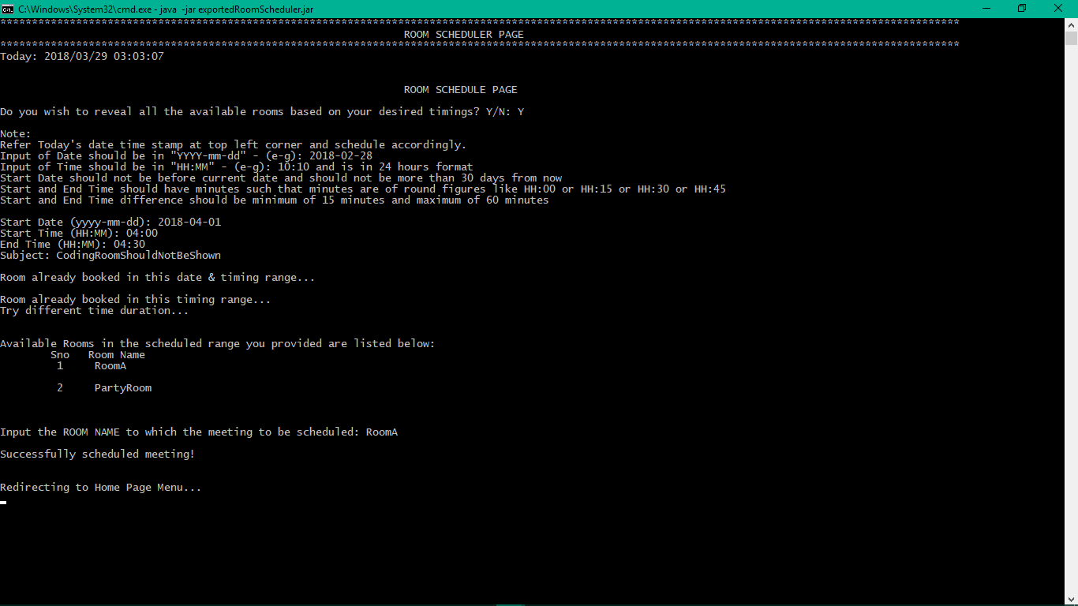Note here that all rooms are revealed except CodingRoom 😊 Program is working fine.

### Scheduled Room Information Page – List Scheduled Rooms Option

* Note that the room scheduling worked as intended. “ALL_ROOMS” reveals all the available rooms.

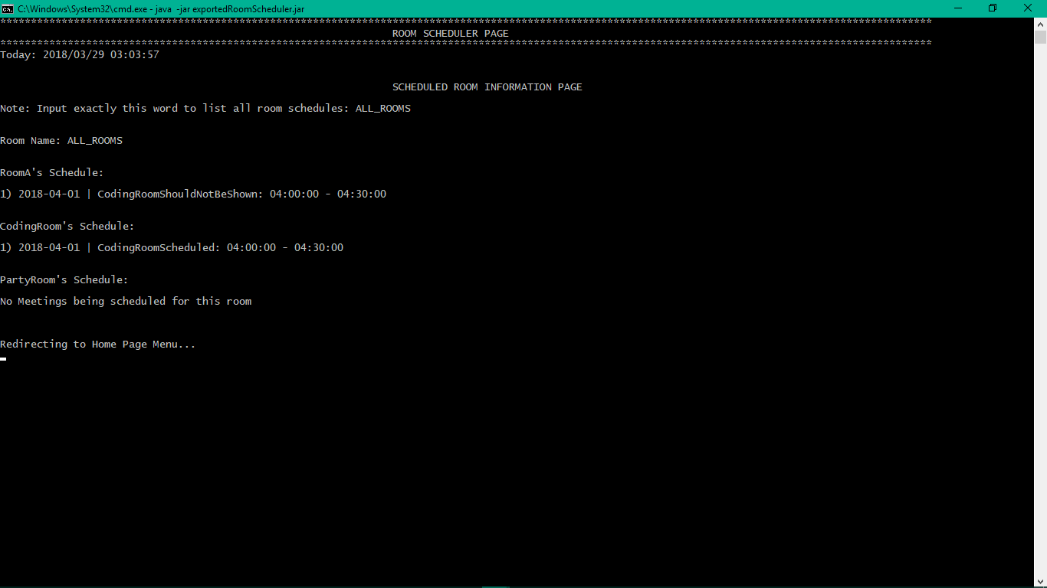

Project Link: <https://github.com/vivekVells/MSCS721-roomScheduler>

Submitted by: Vivek Vellaiyappan Surulimuthu

On: March 29th 2018